South Australia
Victoria Square Act 2005
An Act to provide for the construction and operation of a tramline in Victoria Square; to provide for the designation of certain land within Victoria Square as park land; to make a related amendment to the Passenger Transport Act 1994; and for other purposes.

Contents
1 Short title
2 Commencement
3 Interpretation
4 Dedication of land for purposes of tramline
5 Power to construct tramline etc
6 Designation of other land in Victoria Square as park land or as road
7 Presumption as to closed road boundaries
8 Notice of deposit in GRO
9 Duties of Registrar-General and other persons
Schedule 1—Defined area
Schedule 2—Areas of closed road
Schedule 3—Related amendment
Part 1—Preliminary
1 Amendment provisions
Part 2—Amendment of Passenger Transport Act 1994
2 Amendment of Schedule 3—Public transport assets
Legislative history

The Parliament of South Australia enacts as follows:
1—Short title
This Act may be cited as the Victoria Square Act 2005.
2—Commencement
This Act will come into operation on a day to be fixed by proclamation.
3—Interpretation
(1) In this Act—
areas of closed road means the portions of land in Victoria Square described in Schedule 2 as being areas of closed road, being the areas more particularly delineated in the plan deposited in the GRO as GRO number 267/2005;
defined area means the portion of land in Victoria Square described in Schedule 1 as the area within which a tramline is proposed to be constructed, being the area more particularly delineated in the plan deposited in the GRO as GRO number 268/2005;
GRO means the General Registry Office at Adelaide;
Registrar-General includes the Registrar-General of Deeds;
Victoria Square means Victoria Square in the City of Adelaide.
(2) A reference in this Act to a tramline is a reference to a system of tramlines or light rail transit lines comprising one or more tracks and any ancillary equipment and structures.
4—Dedication of land for purposes of tramline
(1) The Minister may, by deposit of a plan in the Lands Titles Registration Office, dedicate a corridor of land within the defined area for the purposes of a tramline.
(2) The Minister may, however, exclude from the dedicated corridor of land any land that is a public road.
(3) The Minister may, by deposit of a plan in the Lands Titles Registration Office, vary the boundaries of the dedicated corridor of land (provided that the corridor, as so varied, continues to lie wholly within the defined area).
(4) If land is dedicated for the purposes of a tramline under this section—
(a) any other dedication of that land, or trust applying to that land, and any status of the land as community land under the Local Government Act 1999 is taken to be extinguished; and
(b) subject to any instrument under subsection (5), the dedicated land will be under the care, control and management of the Minister.
(5) The Minister may, by instrument in writing, place the dedicated land under the care, control and management of a person or body specified in the instrument subject to such conditions as the Minister specifies in the instrument.
(6) The Minister may, by instrument in writing—
(a) vary or revoke the conditions on which the dedicated land was placed under the care, control and management of a person or body; or
(b) withdraw the land from the care, control and management of that person or body,
and make such related or ancillary provisions as the Minister thinks fit.
(7) The Minister must cause notice of any instrument under subsection (5) or (6) to be—
(a) published in the Gazette; and
(b) given to the Registrar-General,
as soon as practicable after it is made.
(8) The Minister may, in conjunction with the operation of a preceding subsection, by instrument deposited in the GRO make any other provision relating to the status, vesting or management of land as the Minister thinks fit (including by providing for the reservation of any land for a specified purpose).
(9) Any provision made by a plan or instrument under this section will have effect according to its terms and despite any other provision of any other Act or law.
5—Power to construct tramline etc
The Minister responsible for the administration of the Passenger Transport Act 1994 may, for the purpose of the construction and operation of a tramline in Victoria Square, erect such structures on land in the defined area and carry out such other works on land in, or adjacent to, the defined area as the Minister thinks fit.
6—Designation of other land in Victoria Square as park land or as road
(1) The Minister may by deposit of plans in the GRO, on the recommendation of the Surveyor-General, do any of the following:
(a) designate any areas of closed road as being reserved for use as park land or as being incorporated into the Adelaide Park Lands (within the meaning of the Local Government Act 1999) as park land;
(b) designate land within Victoria Square that was, immediately before the commencement of this section, being used as a road (or as part of a road) as being a public road or a part of a public road.
(2) The Minister may, as part of a plan deposited in the GRO under subsection (1)(b), on the recommendation of the Surveyor-General, designate any land within the operation of that paragraph as having been established in accordance with the Roads (Opening and Closing) Act 1991.
(3) The Minister may, in conjunction with depositing a plan in the GRO under this section, or at a later time by plan filed or deposited in the Lands Titles Registration Office, on the recommendation of the Surveyor-General determine the location of the boundary of any road in existence immediately before the commencement of this section where the Surveyor-General has certified that there is a degree of uncertainty as to the location of such a boundary.
(4) The Minister may, in conjunction with the operation of a preceding subsection, by instrument deposited in the GRO make any provision relating to the status, vesting or management of land as the Minister thinks fit (including by providing for the reservation of any land for a specified purpose).
(5) Any provision made by a plan or instrument under this section will have effect according to its terms and despite any other provision of any other Act or law.
7—Presumption as to closed road boundaries
To avoid doubt, the boundaries of those areas of closed road marked as area "A" and area "B" on the plan set out in Schedule 2 will be conclusively presumed to be the boundaries of the road authorised by the Victoria-square Thoroughfare Act 1883.
8—Notice of deposit in GRO
If the Minister deposits a plan or instrument in the GRO under this Act, the Minister must give public notice of that fact within a reasonable time after the plan or instrument is deposited.
9—Duties of Registrar-General and other persons
If a plan or instrument is deposited in the Lands Titles Registration Office or in the GRO under this Act or notification is given by the Minister of an instrument under this Act—
(a) the Registrar-General must amend, cancel or replace any document of title affected and make any entry in or amendment of the Register Book or the Register of Crown leases as required in consequence of the plan or instrument; and
(b) any other person required or authorised under an Act or law to record instruments or transactions relating to land must take any action necessary to give effect to the plan or instrument.

Schedule 1—Defined area
The area within which a tramline is proposed to be constructed is the area bounded by a bold line on the plan below:
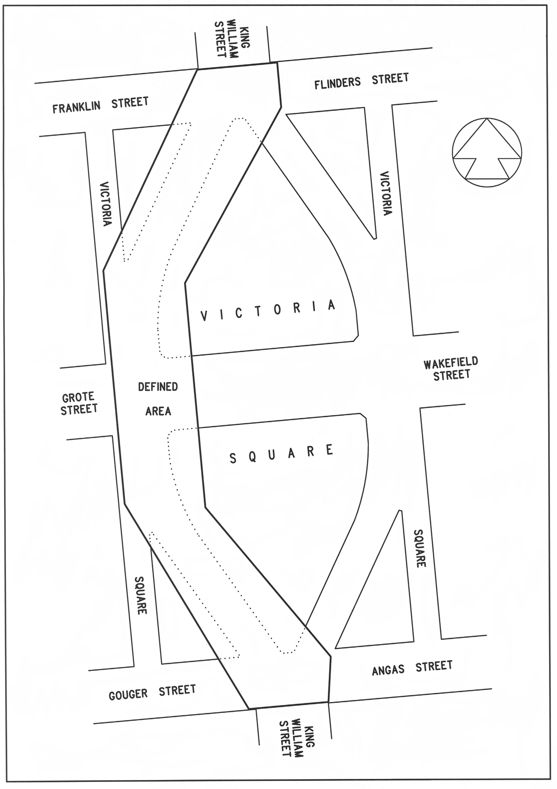

Schedule 2—Areas of closed road
Areas of closed road are indicated by hatching and cross hatching on the plan below:
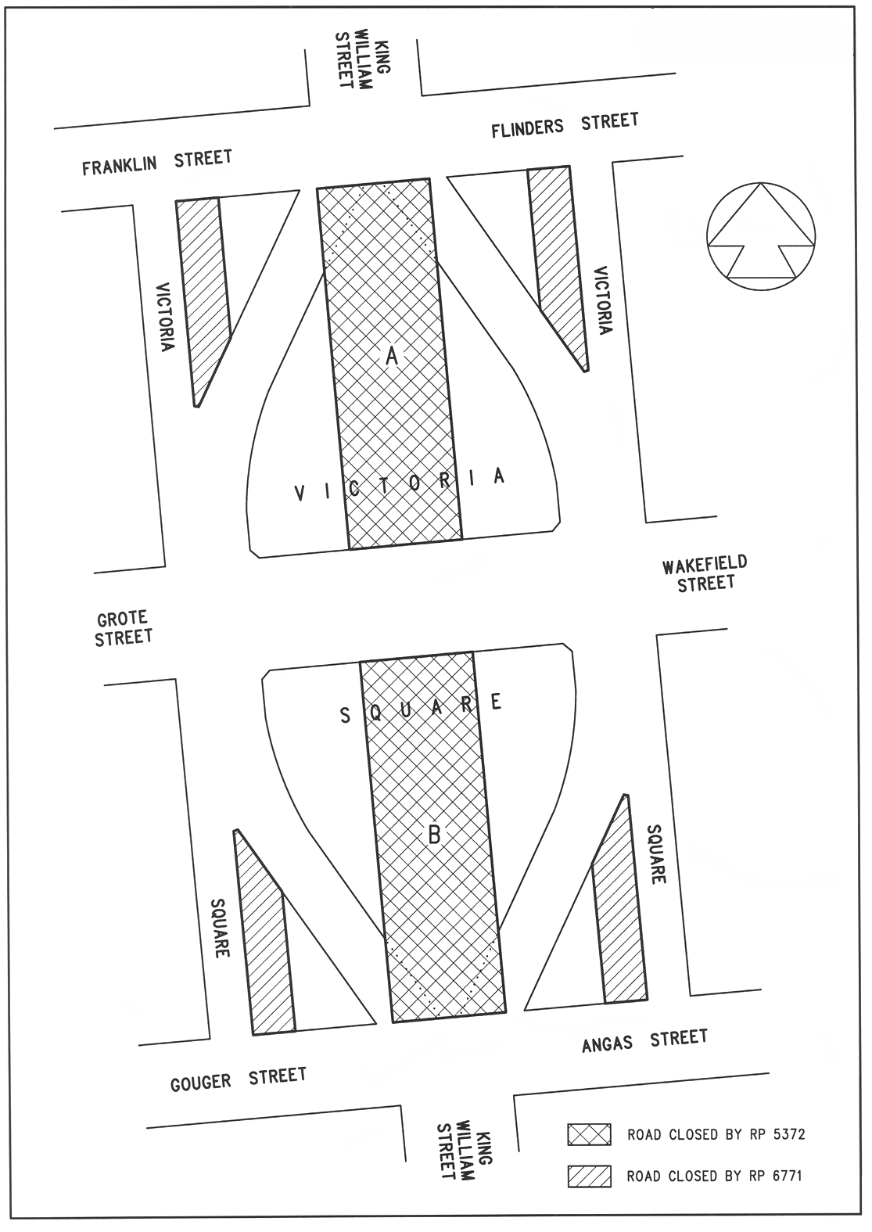

Schedule 3—Related amendment
Part 1—Preliminary
1—Amendment provisions
In this Schedule, a provision under a heading referring to the amendment of a specified Act amends the Act so specified.
Part 2—Amendment of Passenger Transport Act 1994
2—Amendment of Schedule 3—Public transport assets
Schedule 3, clause 4(d)—delete "Victoria Square (Adelaide)" and substitute:
Adelaide

Legislative history
Notes
• For further information relating to the Act and subordinate legislation made under the Act see the Index of South Australian Statutes or www.legislation.sa.gov.au.
Principal Act
Year | No | Title | Assent | Commencement
2005 | 64 | Victoria Square Act 2005 | 1.12.2005 | 12.1.2006 (Gazette 12.1.2006 p44)

